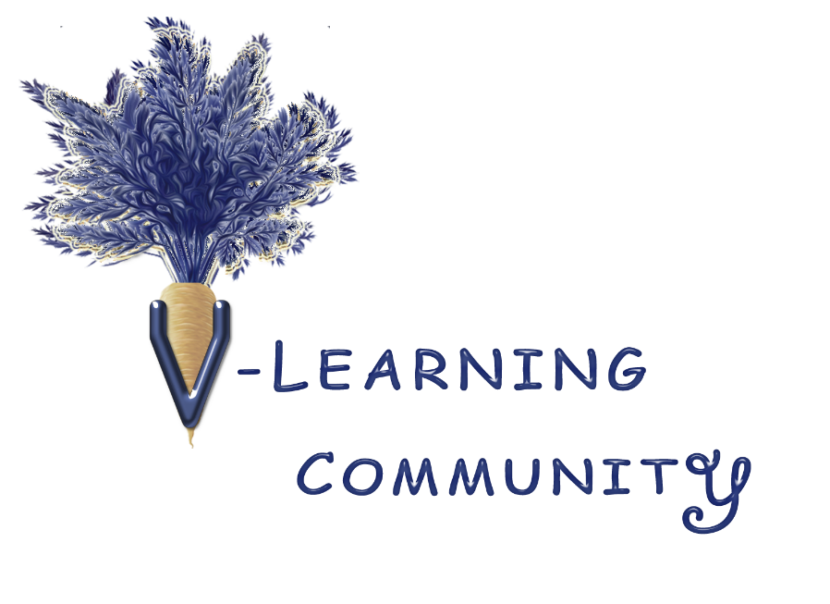

**What’s in a Plan**

*When considering a shift to becoming vegan or vegetarian, thinking through a plan can help you stay on track. This checklist can be used for yourself and anyone you share meals with and/or cook for.*

|  |  |
| --- | --- |
| **Things to Consider** | **My Scenario** |
| **Health** | |
| Should I see my doctor or a nutritionist before making this shift? |  |
| Do I have food allergies or preferences? |  |
| Are there vitamin/supplements I want to consider? |  |
| Are there foods that I may not be allergic to, but I seem to have a sensitivity? For instance, if chocolate upsets my stomach. |  |
| What’s driving my decision? If it’s for my health, would learning about the benefits to animals and the environment also be helpful? Please see *Why Become* step in [V-Learning Community](https://vlearningcommunity-my.sharepoint.com/:b:/g/personal/vlc_vlearningcommunity_onmicrosoft_com/Edk8BBHJs4BPpl-Qfz3DgzQBg5S_1LlH1g6g9EufUwBAqA?e=bJLnq3) for ideas. |  |
| **Community** | |
| Do I need to consider other people when making this decision? Either because we eat together or this decision will impact them in some way? |  |
| Are there friends and family who will support my journey and maybe want to come along? |  |
| Is there a Facebook, Meet-up, or local group with a vegan/vegetarian theme that I could connect with? Does a local city have an upcoming VegFest? |  |
| **Logistics** | |
| Is there a place where I can get the foods I want, and can I get there readily? |  |
| What’s the best way to make the shift, slowly or all at once? For example, maybe start with Meatless Mondays. |  |
| What supplies do I need in my kitchen (blender, food processor, Instant Pot, air fryer, etc.)? |  |
| Do I have time to make meals From Scratch or would finding Substitutes for Everyday Foods work best? Please see *Fundamentals* step in [V-Learning Community](https://vlearningcommunity-my.sharepoint.com/:b:/g/personal/vlc_vlearningcommunity_onmicrosoft_com/Edk8BBHJs4BPpl-Qfz3DgzQBg5S_1LlH1g6g9EufUwBAqA?e=bJLnq3) for ideas. |  |
| Are there systems I can utilize, like cooking a variety of legumes and grains for the week? Please see *Develop a System* step in [V-Learning Community](https://vlearningcommunity-my.sharepoint.com/:b:/g/personal/vlc_vlearningcommunity_onmicrosoft_com/Edk8BBHJs4BPpl-Qfz3DgzQBg5S_1LlH1g6g9EufUwBAqA?e=bJLnq3) for ideas. |  |



This is for information purposes only and does not constitute a recommendation, offer, or solicitation of any kind.

Please visit www.VLlearningCommunity.org for full disclaimer, learning materials, and virtual events.