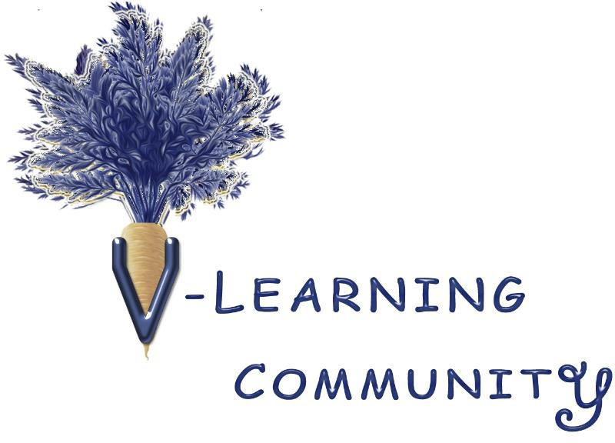

Image Credits for Website, Booklet, and Pamphlet

Cow: Kim Schuster courtesy of Flickr user Timmielee5359 with Creative Common license.
Lamb: Sultry/Sulky/Silly courtesy of Flickr user painterwoman with Creative Common license.

Chicken: Susanna Bolle courtesy of Flicker user s-timestwo with Creative Common license.

Fish: AJ Cann courtesy of Flickr user ajc1 with Creative Common license.
Carrot: Netstrolling Carrot courtesy of Flickr user Netstrolling with Creative Common license.

Lentils: Jessica Spengler Puy Lentils courtesy of Flickr user wordridden with Creative Common license.
Eggplant: Ramesh NG courtesy of Flickr user rameshng with Creative Common license.

Nut branch: John Tann courtesy of Flickr user 31031835 with Creative Common license.

Tree: Washington State Library-the Kilmarnock Weeping Willow courtesy of Flickr user wsl-libdev with
Creative Common license.

Table: Dion Hinchcliffe courtesy of Flickr user dionhinchcliffe with Creative Common license.
Film: Sally Hunter Film Reel ~ Squared Circle courtesy of Flickr user gingermaddy with Creative Common license.

Book: Walters Art Museum Illuminated Manuscripts's Photostream courtesy of Flickr user medmss
with Creative Common license.
Web: Kevin Gill courtesy of Flickr user Kevinemgill with Creative Common license.

Bee: USGS Bee Inventory and… courtesy of Flickr user usgsbiml with Creative Common license.

Additional stock images are from StoryBlocks, VideoHive (EnvatoMarket), Pexel, and ChatGPT.
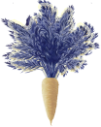
Note: all images were modified by V-Learning Community.
This is for information purposes only and does not constitute a recommendation, offer, or solicitation of any kind.
Please visit www.VLlearningCommunity.org for full disclaimer.

